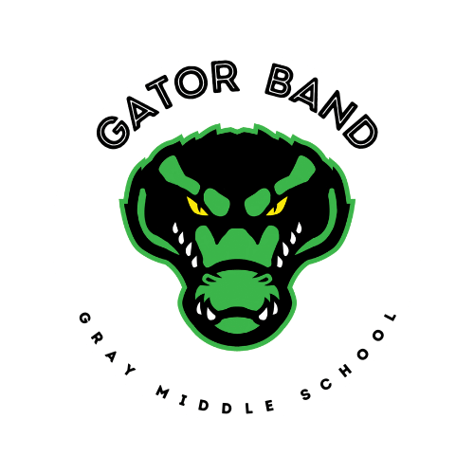
Gray Middle School
Gator Bands
Groveland, Florida ____________________________________________________
PROGRAM ITINERARY Date: April 1, 2023
Event: FBA District 19 Concert MPA
Location: South Lake High School

TIME DESCRIPTION LOCATION
9:00am Call Time SLHS Cafeteria
9:30am Watch Bands SLHS Auditorium
10:45am Get Instruments SLHS Cafeteria
11:00am Warm Up SLHS Chorus Room
11:30am Perform SLHS Auditorium
12:00pm Sight Reading SLHS Band Room
12:30 – 1:30 Lunch (as a group) Concessions
1:30pm Watch Bands SLHS Auditorium
4:00pm Dismissal SLHS Cafeteria

SPECIAL INSTRUCTIONS:
● Students must be wearing the required uniform upon arrival.
● Students are responsible for loading/unloading/moving/storing their own equipment.
● Please bring cash to purchase food at concessions.
Parents are highly encouraged to watch the Gator Band perform and cheer on your Gators.

